**Model Development Phase Template**

|  |  |
| --- | --- |
| Project Title | Online Payments Fraud Detection Using Machine Learning |
| Maximum Marks | 4 Marks |

**Initial Model Training Code, Model Validation and Evaluation Report**

The initial model training code will be showcased in the future through a screenshot. The model validation and evaluation report will include classification reports, accuracy, and confusion matrices for multiple models, presented through respective screenshots.

**Model Validation and Evaluation Report:**

|  |  |  |  |
| --- | --- | --- | --- |
| **Model** | **Classification Report** | **Accuracy** | **Confusion Matrix** |
| **Model 1** | **Better** | **100%** | **Better** |

**Initial Model Training Code:**

Paste the screenshot of the model training code

Home.html

Predict.html

Submit.html

# Model Building

Now our data is cleaned and it’s time to build the model. We can train our data on different algorithms. For this project we are applying four classification algorithms. The best model is saved based on its performance.

# Random Forest Classifier

A function named RandomForest is created and train and test data are passed as the parameters. Inside the function, the RandomForestClassifier algorithm is initialised and training data is passed to the model with the .fit() function. Test data is predicted with .predict() function and saved in a new variable. For evaluating the model, a confusion matrix and classification report is done.

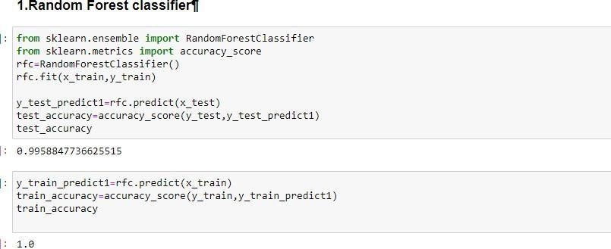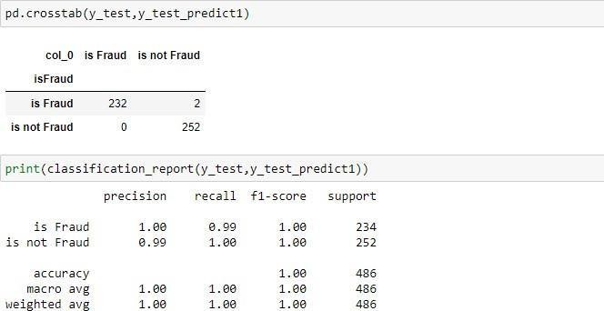

# Decision Tree Classifier

A function named Decisiontree is created and train and test data are passed as the parameters. Inside

the function, the DecisiontreeClassifier algorithm is initialised and training data is passed to the model with the .fit() function. Test data is predicted with the .predict() function and saved in a new variable. For evaluating the model, a confusion matrix and classification report is done.

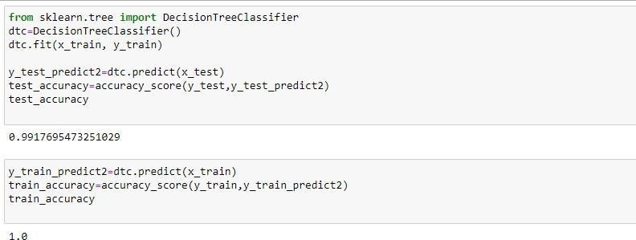

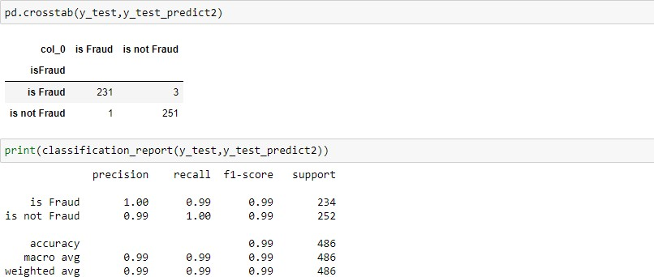

# ExtraTrees Classifier

A function named ExtraTree is created and train and test data are passed as the parameters. Inside the function, ExtraTreeClassifier algorithm is initialised and training data is passed to the model with the .fit() function. Test data is predicted with .predict() function and saved in a new variable. For evaluating the model, a confusion matrix and classification report is done.

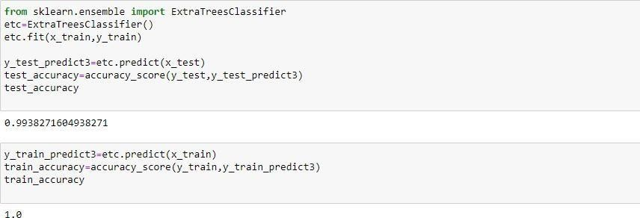

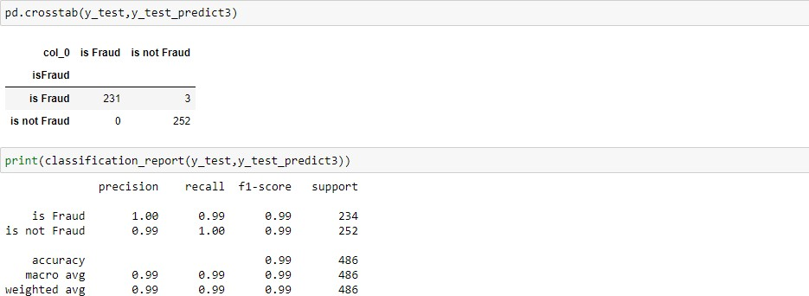

# Support Vector Machine Classifier

A function named SupportVector is created and train and test data are passed as the parameters. Inside the function, the SupportVectorClassifier algorithm is initialised and training data is passed to the model with the .fit() function. Test data is predicted with .predict() function and saved in a new variable. For evaluating the model, confusion matrix and classification report is done

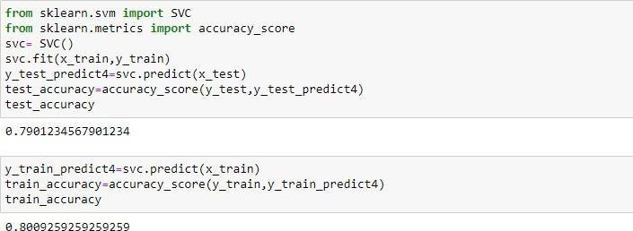

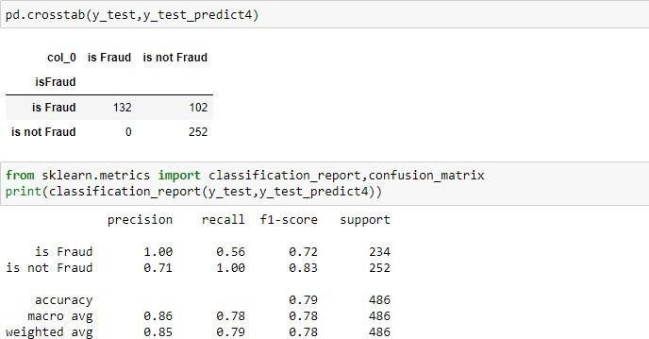

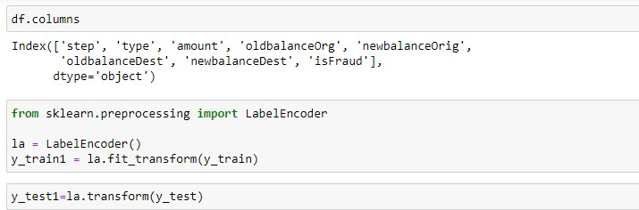 preprocessing class of sklearn. LabelEncoder[source] 0 to n classes-1 as the range for the target labels to be encoded. Instead of encoding the input X, the target values, i.e. y, should be encoded using this transformer.

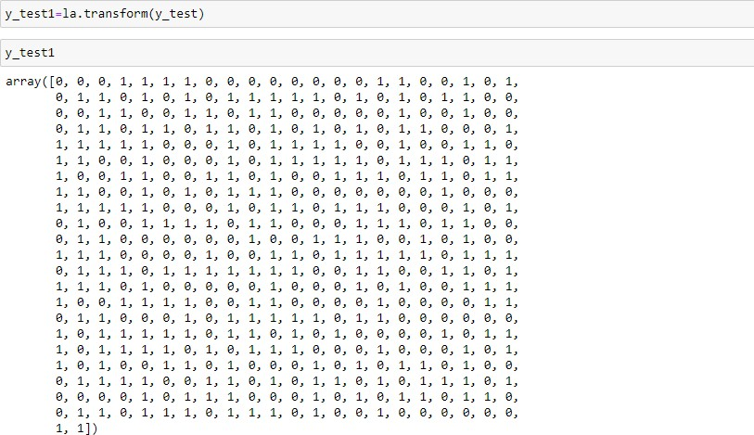

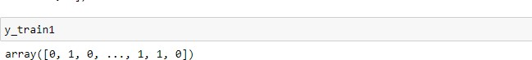

# Xgboost Classifier

A function named xgboost is created and train and test data are passed as the parameters. Inside the function, the xgboostClassifier algorithm is initialised and training data is passed to the model with the .fit() function. Test data is predicted with .predict() function and saved in a new variable. For evaluating the model, confusion matrix and classification report is done

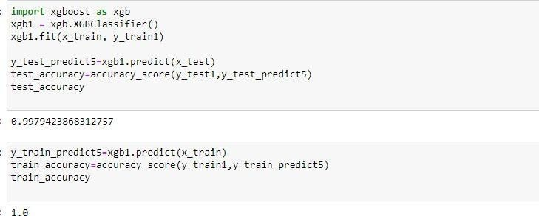

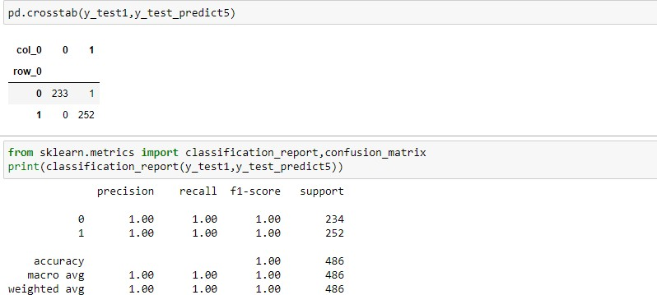

# Compare The Models

For comparing the above four models, the compareModel function is defined.

After calling the function, the results of models are displayed as output. From the five models, the svc is performing well. From the below image, We can see the accuracy of the model is 79% accuracy. .

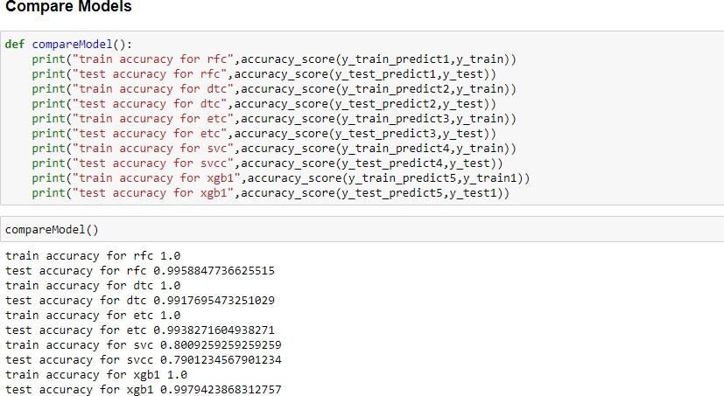

**Evaluating Performance Of The Model And Saving**

**The Model**

From sklearn, accuracy_score is used to evaluate the score of the model. On the parameters, we have given svc (model name), x, y, cv (as 5 folds). Our model is performing well. So, we are saving the model is svc by pickle.dump().

